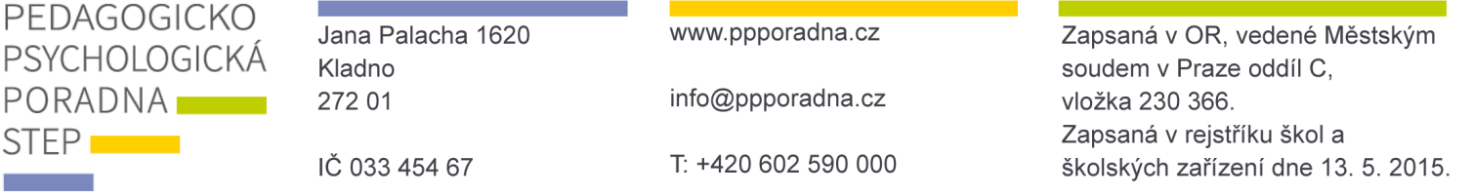
Entered into the Business Register maintained by the Municipal Court in Prague section C, insert 230 366.
Entered into the register of schools and educational institutions on 13 May 2015

QUESTIONNAIRE for the purposes of pedagogical-psychological evaluation – STUDENTS

Dear parents and teachers,

Thank you for entrusting your child or student to the care of the Pedagogical-Psychological Counselling Centre STEP. Please fill in this short questionnaire providing us with basic information concerning the character or status of the child’s issues before our clinical evaluation (consultation).

Child’s name: |  |  |  | Date of birth:
School: |  |  |  | Class:
Parent contact: | phone: |  | email:

Why did you come to PPP STEP?

☐ the child’s educational problems | ☐ the child’s behavioural problems
☐ evaluation of the child’s educational outlook
☐ evaluation of conspicuous behaviour or atypical concerns with the child (such as nervousness, sadness, not fitting in with the group, stereotypical behaviours, etc.)
☐ other issues:

☐ this evaluation is for a second opinion and the child has been evaluated somewhere else (please briefly describe any relevant diagnosis or conclusions, provide an approximate date and the location of the previous evaluation):

For cases of educational or behavioural problems in primary school, we ask the school to provide the following additional information about the child:

Recent classification:
Czech language |  | other subjects taught:
foreign language
mathematics
conduct

Learning:
Reading:
Speed | ☐ appropriate | ☐ slower | ☐ very slow
Understanding | ☐ good | ☐ partial | ☐ lack of comprehension
Fluidity | ☐ uninterrupted | ☐ fragmented | ☐ repeated reading
Writing:
Speed | Legibility | Grammar errors | Specific error rate
☐ appropriate | ☐ legible | ☐ minimal | ☐ leaves out diacritics
☐ slower | ☐ less legible | ☐ average | ☐ leaves out letters
☐ very slow | ☐ illegible | ☐ significant | ☐ confuses letters
 |  |  | ☐ ignores the space between words
 |  |  | ☐ substitutes di-dy, ti-ty, ni-ny
 |  |  | ☐ garbles words

Conspicuous issues in other subjects:

Motivation to work:

Independence in completing tasks:

Achieve better results: | They are more effective when they:
☐ if they can express themselves via speech | ☐ work individually
☐ if they can express themselves in writing | ☐ in group activities
☐ the results are similar | ☐ difficult to evaluate
How the child manages difficult situations in school:
☐ is stressed out | ☐ doesn’t feel any difficulty
☐ is very shy | ☐ is indifferent to failure

Behaviour at school:
In relation to adults |  | In relation to their peers:
☐ appropriate to the situation |  | ☐ appropriate to the situation
☐ fluctuates |  | ☐ fluctuates
☐ common behavioural problems |  | ☐ provokes others
☐ provokes others |  | ☐ unsure | ☐ introverted
☐ unsure | ☐ introverted | ☐ verbally aggressive | ☐ physically aggressive
☐ defiant |  | ☐ often in conflict
☐ impulsive |  | ☐ other – write out:
☐ other – write out:

Work and social skills:
Position in the group:

Concentration of attention:

Work speed:

Current form of assistance provided to the child by the school:

Is provided with a pedagogical support plan: | YES NO
Utilises an individual educational plan: | YES NO
If a pedagogical support plan or an individual educational plan are being used, please attach it and provide a brief evaluation of its progress.

In Kladno on:
signature of the class teacher
or school counsellor
signature of the child’s legal guardian

